

Revision History 3
1. Scope 3
2. About the Document 3
3. Proposed System 3
4. Approach 3
5. Process Flow Chart 4
6. Deployment Diagram 5
7. Process flow chart for INAS Internal mechanism 6
8. Glossary of term 7

Revision History
Version | Date | Author | Description
1.0 |  |  | Initial Version / Draft

Scope
This application will be deployed in Microsoft Azure cloud computing platform (hosting provider). Below is the scope of the project.

About the Document
This document describes New provisioning process for retail customer provisioning through FTTH and business requirement specification for automation of same for “Citycom Networks Private Limited” referred as SPECTRANET in rest of the document.

Proposed System
It is required to automate As-Is process to avoid dependency of customer service provisioning on NOC and hence enabling Faster delivery Opex saving by eliminating need of manual provisioning by NOC engineer

Approach
- A mobile base Application which can talk to INAS and CRM.
- SDA engineer will manually enter the below details in the app
- Serial No of ONT
- Society ID, Customer Account Number
- Splitter Details & BDB information on which customer is connected
- Mobile App will check with CRM for plan which is required to push to INAS
- Mobile App will push the OLT/ONT directly to INAS to provision the customer.
- SDA Engineer will check the internet services with customer & close the provisioning order

Process Flow Chart 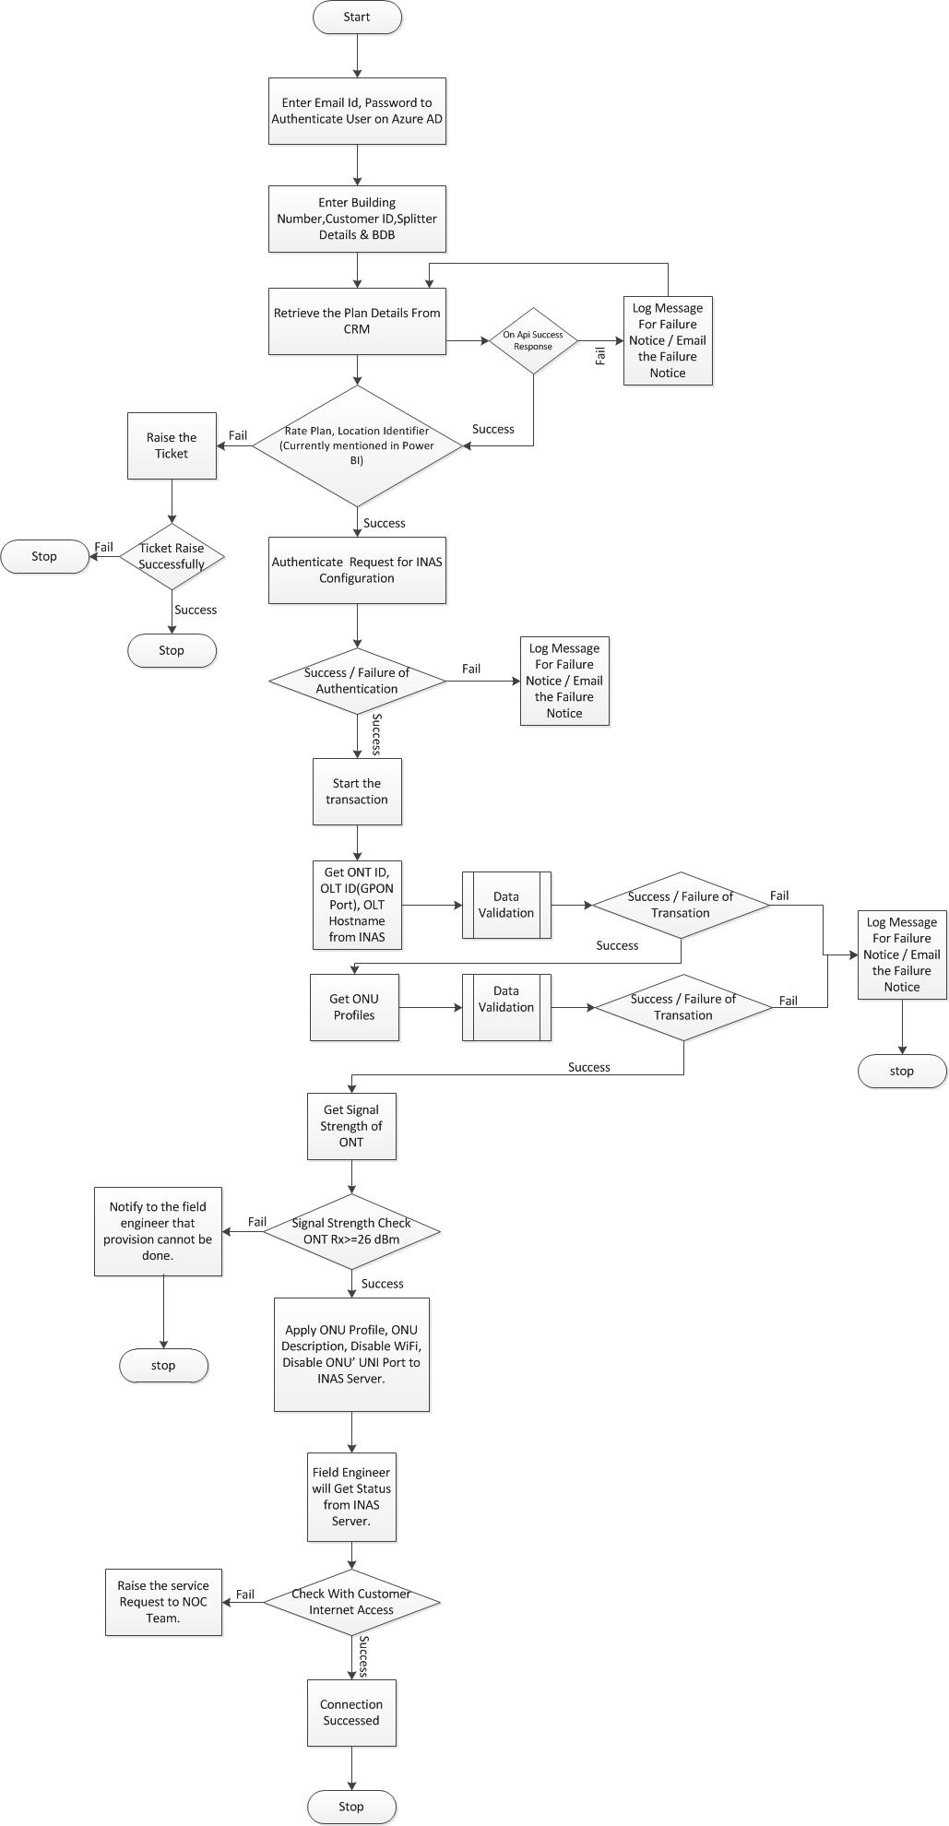

Step Number | Step Description | Corresponding API Call | INPUT PARMS | OUTPUT PARMS
1 | Enter Building Number,Customer ID,Splitter Details & BDB in mobile application. | NA | NA | NA
2 | Retrieve the Plan Details From CRM | getPlanDetails() | accountId | PlanDetails[]
3 | Authenticate / Authorize the Configurations | NA | NA | NA
4 | Get OLT ID from INAS | getOltId() | Splitter Details & BDB | OLT Id
5 | Get ONT ID from INAS | getOntId() | OLT Id | ONT Id
6 | Get GPON Port Details | getGponPortId() | ONT Id | Signal Strength
7 | Update Rate plan, Description on INAS Server. | updateDetails() | Rateplan,Desc | Status

Deployment Diagram

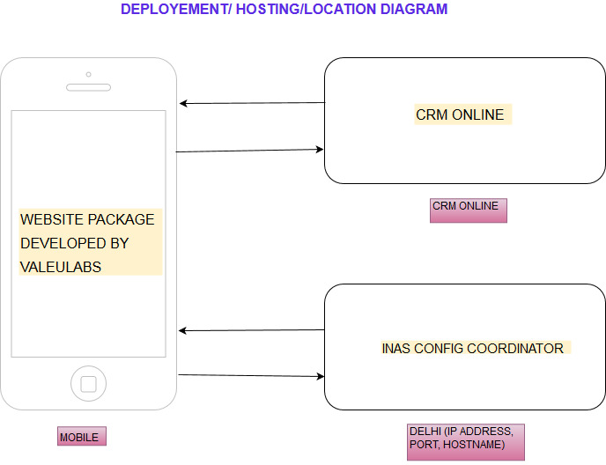

Process flow chart for INAS Internal mechanism

- Flow chart Diagram: INAS Process As Is

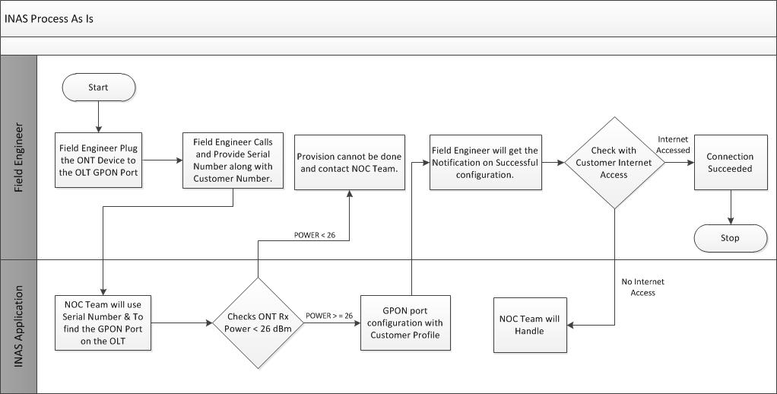
- Flow chart Diagram : INAS Process To Be

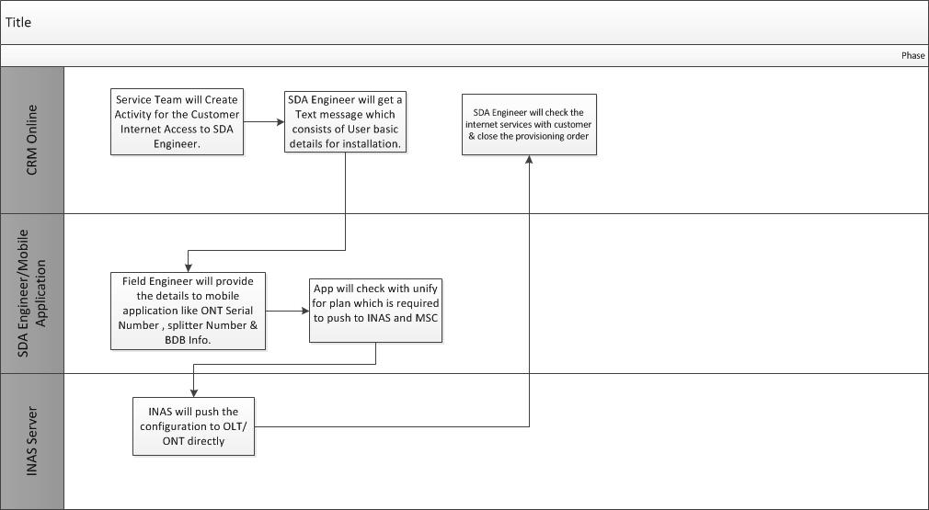

Glossary of term

Type | Abbreviation | Usage
OLT | Optical Line Terminal | Converting the standard signals used by a FiOS service provider to the frequency and framing used by the PON system.
ONU/ONT | Optical Network Units/ Optical Network Terminals | The ONT (also called the modem) connects to the Termination Point (TP) with an optical fiber cable, and connects to your router via an LAN / Ethernet cable. It translates light signals from the fiber optic line from your TP into electronic signals that your router can read
GPON | Gigabit Passive Optical Networks | GPON is a point-to-multipoint access mechanism. Its main characteristic is the use of passive splitters in the fiber distribution network, enabling one single feeding fiber from the provider's central office to serve multiple homes and small businesses.

